

**Functional Specifications**

Introduction 3

EdLighten Conceptual Framework 3

EdLighten Roles 3

School Admin Role 4

1.1. School Admin 4

1.1.1. On-Boarding 4

1.1.2. Login 6

1.1.3. Profile 7

1.1.4. Timeline 8

1.1.5. Calendar 16

1.1.6. Inbox 17

Teacher Role 24

1.2. Teacher 24

1.2.1. On-Boarding 24

1.2.2. Login 26

1.2.3. Profile 27

1.2.4. Left Menu 28

1.2.5. Timeline 31

1.2.6. Timeline 31

1.2.7. Calendar 44

1.2.8. Inbox 44

Parent Role 51

1.3. Parent 51

1.3.1. On-Boarding 51

1.3.2. Login 53

1.3.3. Profile 54

1.3.4. Left Menu 55

1.3.5. Timeline 57

1.3.6. Timeline 57

1.3.7. Calendar 61

1.3.8. Inbox 61

Student Role 63

1.4. Student 63

1.4.1. Login 63

1.4.2. Timeline 63

1.4.3. Calendar 63

1.4.4. Inbox 63

# Introduction

This document will provide detailed functional specifications for mobile version of EdLighten digital platform. Document has been structured to provide role wise / screen wise / activity wise functional specification.

# EdLighten Conceptual Framework

# EdLighten Roles

Following are the roles for EdLighten Mobile version:



## School Admin Role

* 1. School Admin
     1. On-Boarding
        1. Splash screen will appear.

* + - 1. On first time use, School Admin will be presented with the OTP option provided he is already been setup by EdLighten. In case, not yet “setup”, School Admin will be asked to contact EdLighten.

* + - 1. OTP once authenticated will allow user to select username and password to be stored with his account, once logged in the user will not be asked for username and password because the IMEI will be in logged in state. If the user wishes he can logout, so the option for logout should be in the left menu. When he logs out the users logged in state will change to Logged Out and he would be shown the login screen on next login.

After onboarding is completed user will be taken to profile screen where he can modify or skip to edit at a later time.

* + 1. Login
       1. If user logged out and clicked on the EdLighten app icon, he can login as follows:

* + - 1. If user is in logged in state he would be directly taken to the Timeline page.
      2. If user wants to log in from some other device, he can log in using user name and password as in 1.1.2.1.
    1. Profile
       1. Profile will be display only with a next button on the bottom and a camera icon along with photo id and is editable. Fields should include the ones as depicted in the picture below along with following:  
          * Address  
          * Job role (such as accounts, principal, etc.)  
          (employee id in the picture below should be removed).



* + - 1. In case, user want to change the picture, he can click on camera icon and following screen will appear:

* + 1. Timeline
       1. School admin can only post announcements, and/or notifications, memory posts, events, fees reminders, survey, etc for the entire school branch such as revised school timings, winter uniform, sports event, etc.
       2. User can see a hovering + icon to select and post a particular post type
       3. On clicking + icon, home screen will fade out and a list of items that can be posted will appear



* + - 1. User can select a particular post item and follow the screen as follows for each post type:
         1. Create Announcement



There should be an Audience field as well to select the role, for instance, All, Parent, Teachers, Students etc.

* + - * 1. Create Event

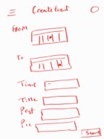  
There should be an Audience field as well to select the role, for instance, All, Parent, Teachers, Students etc.

* + - * 1. Create Memory
        2. Create Poll/Survey

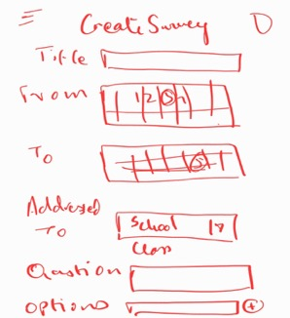

There should be an Audience field as well to select the role, for instance, All, Parent, Teachers, Students etc.

* + - * 1. Create Action

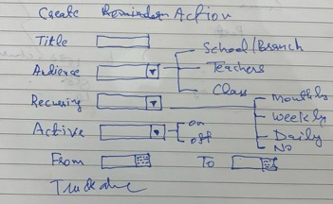

Add Post and Picture fields over here.

School Admin can view timeline for all the posts that are related to admin and are posted by him

School Admin is a super admin role which is above the Parents and Teachers. The school admin will have complete visibility of the posts of the complete school branch

* + - 1. Top banner will look like this by default

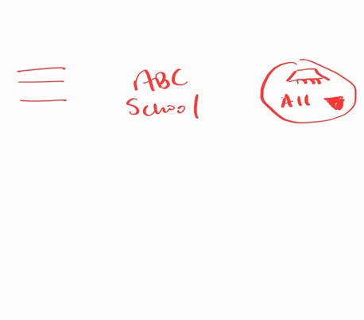

By default the view would only show the admin specific posts and the interactions around that, Instead of the profile pic that was visible on the right hand side, the pull down menu would have the following options and once selected it will dictate the view that needs to be rendered:

* Super Admin View
* All
* Class 1
* ..
* Class 11
  + - 1. After the top Banner Admin will have the following filter panel

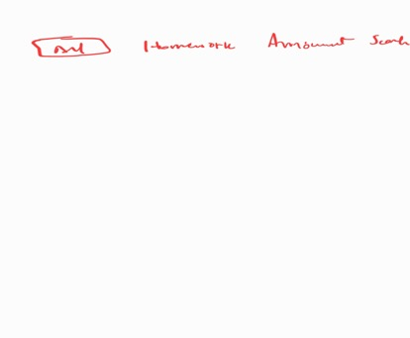

* + - 1. Below Top level View will be in the form of the banner of card which will show the summary information of the Poll/Actions

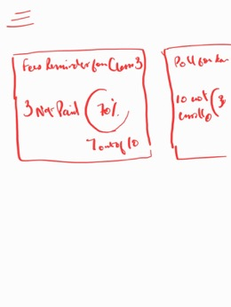

Default view will display will only the posts that he has created.

* + - 1. View Post (Announcement/Memory) – Admin can comment/update as well as do the moderation of it as well (Allow/Disallow/delete comments from a specific users). Below is the example of the moderation.

Superadmin can click here to view all moderated/unmoderated comments

Superadmin can edit/delete a post of any author.

* + - 1. When any Author posts, he is the owner of it and he needs to take responsibility of the post & its comments. If there is an obnoxious comment, then it will be displayed for the person who commented but it will not displayed for the rest of the audience, and then the author can delete it. If the author deletes it, there will be generic message will be sent to the user. This message will be sent to the users’ inbox.
      2. Moderation of Comments:   
         Moderation is a feature provided to the author to allow him to approve or reject comments on his post. It will be available by default and would display approve and reject options for all unmoderated comments. For reject action an additional confirmation would be required. When a comment is rejected it is removed from the list of comments for the author, but it is visible to the super admin. For approved comments the delete comment option would also be there to allow the super admin to delete comments. Delete will also require additional confirmation.

The comment author would be able to view his comments till the time it is disapproved by the post author. This unmoderated comment will not be publicly visible. A comment will only become public when it is approved. Once the post author decides to disapprove, an automated message would be sent to the comment author explaining that the comment was valuable and has been noticed for further discussion.

As a super admin the moderated/unmoderated comments would be visible. The unmoderated comments would display approve and reject actions only if super admin is the author. He would also see the rejected/deleted comments of the post authors. He can also reject any comment he seems fit.

Super admin will have the visibility of the all the deleted comments.

View Event (individual post) – Admin can comment/update as well as do the moderation of it as well (Allow/Disallow/delete comments from a specific users)  
  
Superadmin can edit/delete an event of any author.

Superadmin can click here to view all moderated/unmoderated comments

* + - 1. View Poll (summary based card as depicted above in the picture)

Submit

Admin can see the progress of the poll

* + - 1. View Action (Summary based card as depicted above in the picture)

For each option, the super admin will be able to see the number of responses for each action. E.g. Out of the audience 70% have actioned on Yes and 30% have actioned No.

All view which will display the complete information of the branch.

(Assuming each individual post has a heading which has a class as well). This will include all the posts of the complete school in an organized manner which can be filtered as well.

Class Specific view which will display all the information of that specific class

* + 1. Calendar

The calendar view would show all the events based on the level selected, for instance for All, it would display the entire school level events and class level events. For a specific class it would show what that class would be seeing in their calendars.

There should be edit capability as well.

Search will not show here but instead should be one level below, this should contain the selected profile icon, either particular class level, admin level or school level.

* + - 1. Search for Events

If user clicks on the search icon they can search by the content of an event.

* + 1. Inbox

The inbox view will consist of only the super admin view regardless of the level selected using the top right drop down. There will be no selection to change the level available in the Inbox view, this will only be available on the web.

* + - 1. Search Messages

Search messages will allow the user to search on all messages including keywords appearing in the message body, as well as receiver name etc.

* + - 1. Plus Icon

When user selects + the To field will show a search button on the side, one option is to start typing and the typeahead will suggest names for auto completion. The additional option is to display a search button for searching for a contact.

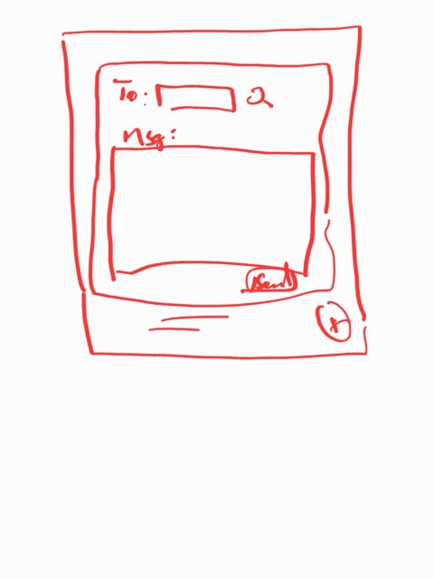

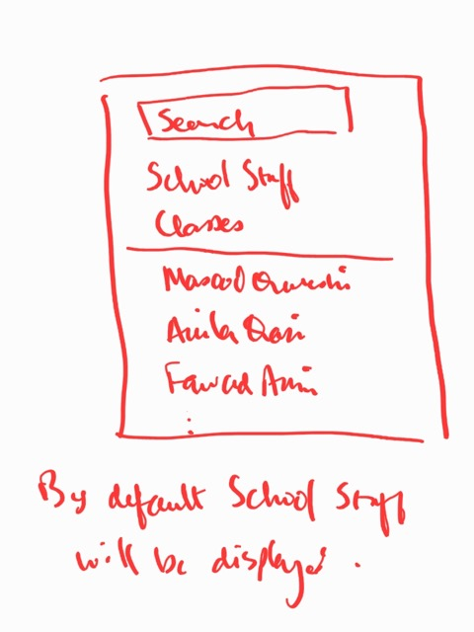

By default, admin or teachers would be sending the message to each other, so School staff should be displayed.

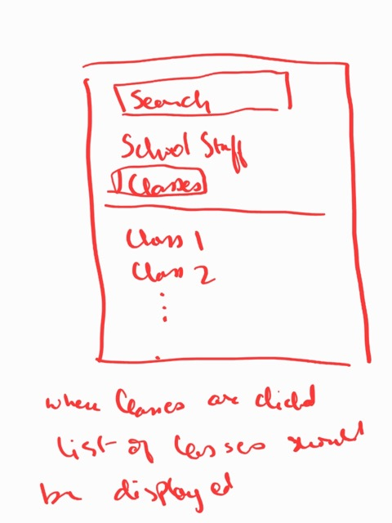

If you select School Staff, only school staff would be displayed, but if you select classes then a list of classes would appear.

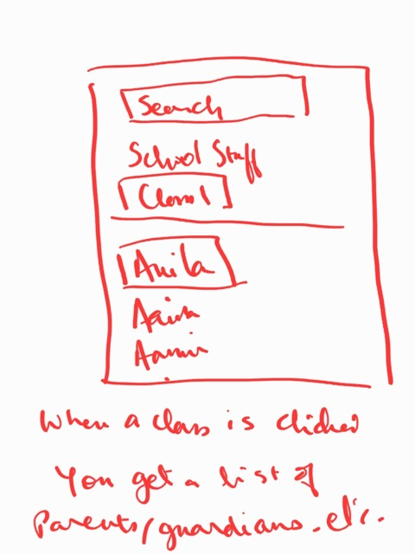

Selecting a class and section displays the list of students/children and you could select one of them to move to the next screen.

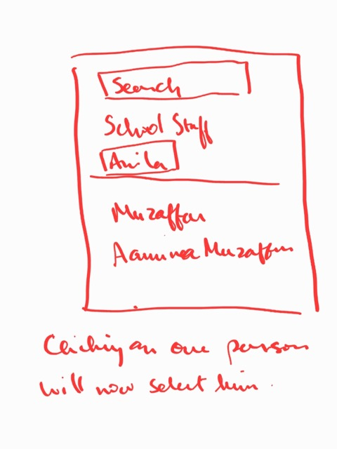

Clicking on one of the parent will now select him, this could be a list of guardians and also tution teachers as well. There should be an All option as well here allowing the sender to send it to all interested parties around the child.



## Teacher Role

* 1. Teacher

Teacher would mainly be responsible to assign tasks to students and also to inform parents of the daily activities done at the school.

* + 1. On-Boarding
       1. Splash screen will appear.

* + - 1. On first time use, Teacher will be presented with the OTP option provided he is already been setup by School Admin. In case, not yet “setup”, teacher will be asked to contact Super Admin.

* + - 1. OTP once authenticated will allow user to select username and password to be stored with his account, once logged in the user will not be asked for username and password because the IMEI will be in logged in state. If the user wishes he can logout, so the option for logout should be in the left menu. When he logs out the users logged in state will change to Logged Out and he would be shown the login screen on next login.

After onboarding is completed user will be taken to profile screen where he can modify or skip to edit at a later time.

* + 1. Login
       1. If user logged out and clicked on the EdLighten app icon, he can login as follows:

* + - 1. If user is in logged in state he would be directly taken to the Timeline page.
      2. If user wants to log in from some other device, he can log in using user name and password as in 1.1.2.1.
    1. Profile
       1. Profile will be display only with a next button on the bottom and a camera icon along with photo id and is editable. Other Fields are not editable should include the ones as depicted in the picture below along with following:  
          * Address  
          * Job role (such as accounts, principal, etc.)  
          (employee id in the picture below should be removed).

* + - 1. In case, user want to change the picture, he can click on camera icon and following screen will appear:

* + 1. Left Menu
       1. Mark Absentees

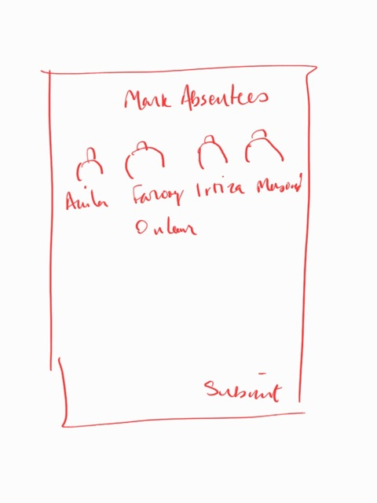

* + - 1. Apply for Leave

* + 1. Timeline
    2. Timeline
       1. Teacher can only post announcements, and/or notifications, memory posts, events, fees reminders, survey, etc for the class only to which he is assigned.
       2. User can see a hovering + icon to select and post a particular post type
       3. On clicking + icon, home screen will fade out and a list of items that can be posted will appear. Create Event will also be there.

* + - 1. User can select a particular post item and follow the screen as follows for each post type:
         1. Create Announcement

* + - * 1. Create Event



* + - 1. Create Homework

When create homework is clicked the following screen is displayed

When Attach file is selected the following options are displayed and the user will be able to select the location:

* Document
* Gallery Picture
* Camera

* + - * 1. Create MCQ

The audience will only be the class or parents, it cannot be the school for the teacher role. The Poll feature can also be used as a quiz for the student.

When selected the MCQ will show two types that the teacher can select

* Poll
* Quiz (typically for students)



* + - * 1. Create Action



Add Post and Picture fields over here.

Teacher can view timeline for all the posts that are posted by him

* + - 1. Top banner will look like this by default



By default the view would only show the class specific posts to which the teacher belongs and the interactions around that, also the school level posts would also be visible to the teacher. Teacher can select a class from the drop down.

* + - 1. After the top Banner Admin will have the following filter panel



* + - 1. Cards:

Below Top level, View will be in the form of the banner of card which will show the summary information of the Quiz/Poll/HOMEWORK Checking

The todo cards is also a way to show the prioritized list of actions the user has to take for the day. For instance the teacher has to submit the planner and check homework that was completed. These are the top actions that will be visible in card form.

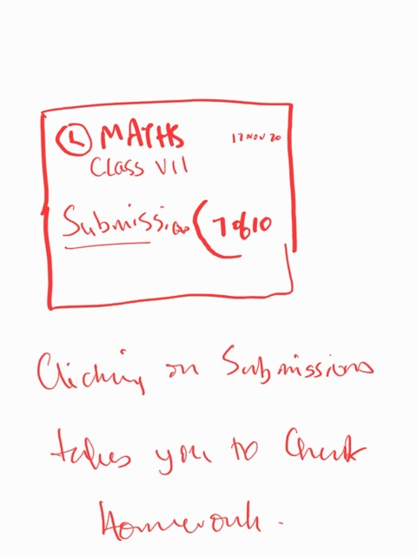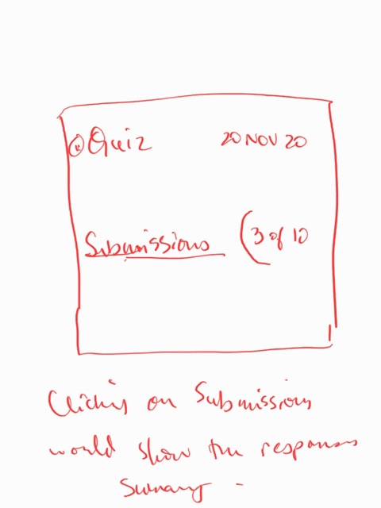

Default view will display will only the posts that he has created.

* + - 1. View Post (Announcement/Memory) – Admin can comment/update as well as do the moderation of it as well (Allow/Disallow/delete comments from a specific users). Below is the example of the moderation.

Teacher can click here to view all moderated/unmoderated comments for his posts only otherwise he will only see moderated comments.

Author can edit/delete a post of himself only.

* + - 1. When any Author (teacher who originally posted) posts, he is the owner of it and he needs to take responsibility of the post & its comments. If there is an obnoxious comment, then it will be displayed for the person who commented but it will not displayed for the rest of the audience, and then the author can delete it. If the author deletes it, there will be generic message will be sent to the user. This message will be sent to the users’ inbox.
      2. Moderation of Comments:   
         Moderation is a feature provided to the author to allow him to approve or reject comments on his post. It will be available by default and would display approve and reject options for all unmoderated comments. For reject action an additional confirmation would be required. When a comment is rejected it is removed from the list of comments for the author, but it is visible to the super admin. For approved comments the delete comment option would also be there to allow the super admin to delete comments. Delete will also require additional confirmation.

The comment author would be able to view his comments till the time it is disapproved by the post author. This unmoderated comment will not be publicly visible. A comment will only become public when it is approved. Once the post author decides to disapprove, an automated message would be sent to the comment author explaining that the comment was valuable and has been noticed for further discussion.

As a super admin the moderated/unmoderated comments would be visible. The unmoderated comments would display approve and reject actions only if super admin is the author. He would also see the rejected/deleted comments of the post authors. He can also reject any comment he seems fit.

Super admin will have the visibility of the all the deleted comments.

View Event (individual post) – Teacher can comment/update as well as do the moderation of it as well (approve or reject)

* + - 1. View Poll (summary based card as depicted above in the picture)

Percentages will also be visible here for the teacher for his polls

Teacher can see the progress of the poll

* + - 1. View Action (Summary based card as depicted above in the picture)

For each action, the teacher will be able to see the options they need to select, otherwise if the action is for others, the view would only be fyi and not for action.

* + 1. Calendar

The calendar view would show all the events based on the level selected, for instance for All, it would display the entire school level events and class level events. For a specific class it would show what that class would be seeing in their calendars.

Search will not show here but instead should be one level below, this should contain the selected profile icon, either particular class level.

* + 1. Inbox

The inbox view will consist of only the Teacher view regardless of the level selected using the top right drop down.

* + - 1. Search Messages

Search messages will allow the user to search on all messages including keywords appearing in the message body, as well as receiver name etc.

* + - 1. Plus Icon

When user selects + the To field will show a search button on the side, one option is to start typing and the typeahead will suggest names for auto completion. The additional option is to display a search button for searching for a contact.





By default, admin or teachers would be sending the message to each other, so School staff should be displayed.



If you select School Staff, only school staff would be displayed, but if you select classes then a list of classes would appear.



Selecting a class and section displays the list of students/children and you could select one of them to move to the next screen.



Clicking on one of the parent will now select him, this could be a list of guardians and also tution teachers as well. There should be an All option as well here allowing the sender to send it to all interested parties around the child.



## Parent Role

* 1. Parent

Parent would mainly be responsible to assign tasks to students and also to inform parents of the daily activities done at the school.

* + 1. On-Boarding Parent Himself
       1. Splash screen will appear.

* + - 1. On first time use, Parent will be presented with the OTP option provided he is already been setup by School Admin. In case, not yet “setup”, parent will be asked to contact School Admin.

* + - 1. OTP once authenticated will allow user to select username and password to be stored with his account, once logged in the user will not be asked for username and password because the IMEI will be in logged in state. If the user wishes he can logout, so the option for logout should be in the left menu. When he logs out the users logged in state will change to Logged Out and he would be shown the login screen on next login.

After onboarding is completed user will be taken to profile screen where he can modify or skip to edit at a later time.

* + 1. Onboarding Child

Once the Parent is on-boarded, the journey will continue and the parent will be asked to register his child(s).

Edlighten

Kindly configure your child account

User Name

Password

Re-enter Password

Submit

* + 1. Login
       1. If user logged out and clicked on the EdLighten app icon, he can login as follows:

* + - 1. If user is in logged in state he would be directly taken to the Timeline page.
      2. If user wants to log in from some other device, he can log in using user name and password as in 1.1.2.1.
    1. Profile
       1. Profile will be display only with a next button on the bottom and a camera icon along with photo id and is editable. Fields (not editable) should include the ones as depicted in the picture below along with following:  
          * Address  
          * Parental role (such as father, mother, etc.)  
          (employee id in the picture below should be removed).

* + - 1. In case, user want to change the picture, he can click on camera icon and following screen will appear:

* + 1. Left Menu
       1. Apply for Leave

* + 1. Timeline
    2. Timeline
       1. Parent can only post comments in response to posts.
       2. Top banner will look like this by default, Instead of the top right dropdown, there will be the picture of the student of whose timeline the parent has chosen.



By default the view would only show the class specific posts to which the parents kid belongs and the interactions around that, also the school level posts would also be visible to the parent.

* + - 1. After the top Banner parent will have the following filter panel



* + - 1. Below Top level View will be in the form of the banner of card which will show the summary information of the Poll/Actions/Homework due for the student/parent



Default view will display only the actions relevant to the class or the kid.

* + - 1. View Post (Announcement/Memory) – Parent can comment/update A screenshot of a social media post

         Description automatically generated

Parent can click here to view all moderated comments

* + - 1. View Poll (summary based card as depicted above in the picture)

Percentages will also not be visible here for the parent

Parent cannot see the progress of the poll

* + - 1. View Action (Summary based card as depicted above in the picture)

For each action, the parent will be able to see the options they need to select

* + 1. Calendar

The calendar view would show all the events based on the student selected, for instance for Fahad, it would display the entire school level events and class level events.

Search will not show here but instead should be one level below, this should contain the selected profile icon

* + 1. Inbox

The inbox view will consist of only the parent view.

## Student Role

* 1. Student
     1. Login

**Edlighten**

Kindly enter your credentials here

User Name

Password

Submit

Forgot your password?

* + 1. Timeline

XYZ Public School

Social Studies

Due by: 30th Nov, 2020

English

Due by: 25th Nov, 2020

Maths

Due By: 20th Nov,2020

Calendar

Inbox

Homework

Home

Home-Work

XYZ Public School

Social Studies

Due by: 30th Nov, 2020

English

Due by: 25th Nov, 2020

Maths

Due By: 20th Nov, 2020

MATHS

20th Nov 2020

Kindly Refer to the question 4.7 from your workbook and paste your comments and submit

Provide Attachment

Enter your comments here

Submit

Calendar

Inbox

Home

Homework

Homework Display Interface:

This view will display all the submitted home-works here.

XYZ Public School

MATHS

Homework_no.1

Homework_no.2

ENGLISH

Homework_no.3

Homework_no.1

Homework_no.3

Homework_no.2

Calendar

Inbox

Home

Homework

Homework Edit Interface:

XYZ Public School

MATHS

Display Submitted Homework Details Here

Homework_no.1

Replace Attachment

Attachment file here and can be changed and replaced here

Calendar

Inbox

Home

Homework

Homework View Interface:

When the teacher has marked the homework/assignment, it will be displayed only here and will not be able to edit.

XYZ Public School

MATHS

Homework will be displayed here only for view only purposes

Homework_no.1

Calendar

Inbox

Home

Homework

* + 1. Calendar

Default calendar view can be provided

* + 1. Inbox

Student will be able to communicate with the teacher using the inbox